- What do waves transfer?
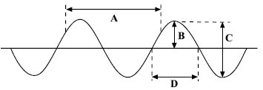
a. What type of wave is shown above?
b. Which letter represents the amplitude of the wave?
c. Which letter shows the wavelength?
- Draw a longitudinal wave and label a compression, rarefaction and the wavelength.

- The diagram shows a cork floating on a water wave which has a frequency of 0.5 Hz. Which letter shows where the cork will be 2 seconds later?

- What is meant by the period of a wave?

- State the two equations that you can use to calculate wave speed.

- A sound wave has a frequency of 240Hz and a wavelength of 1.38m. Calculate the velocity of this sound wave. Show clearly the formula you use for this calculation.
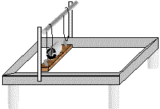
- The diagram shows a ripple tank, used to generate waves in the laboratory. Describe the measurements that must be made in order to calculate the velocity of water waves in the tank.

- (Physics HT only) The sound waves from a noisy jet travel from the air into water. Which property of the wave will not change?

- (Physics HT only) The Eiffel Tower is made of iron. The speed of sound in iron is 4000m/s. Someone at the top hits the iron with a hammer and the sound can be heard at the bottom 0.08s later. How tall is the Eiffel Tower?

- (Physics only) The diagram shows a light ray striking a plane mirror. Copy and complete the diagram (include all labels).
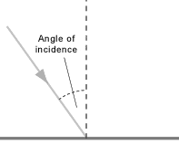
- (Physics only) When light strikes a black curtain, very little light gets reflected. What happens to the light?
- (Physics only) Explain why you cannot see your reflection when you look into a piece of white plastic held in front of you.
- (Physics only) When waves flow from deep water to shallow water the wave can bend (diffract). What happens to the speed of the wave to allow this to happen?
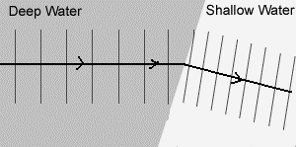
- (Physics HT only) Describe how sound waves in the air are converted to vibrations in solids by the ear.
- (Physics HT only) Which of the following represents the frequency range of human hearing?
200Hz to 2000Hz 20Hz to 20 000Hz 2000Hz to 200 000Hz
- (Physics HT only) What are ultrasound waves?
- (Physics HT only) The picture shows the ultrasound image of an unborn baby. Explain how ultrasound is able to produce an image from the outside of the mother.
- (Physics HT only) Seismic waves are described as P or S waves. Copy the table and put ticks in the correct column to show the difference in these two seismic waves.
Wave type | Longitudinal wave | Fastest wave | Can travel through liquid and solid
P wave
S wave

- (Physics HT only) Describe how P and S seismic waves can be used to show part of the Earth’s core is liquid.

