A. Hormonal control in humans – Part 1
- What is the endocrine system composed of?
- What is a hormone?
- How are hormones carried around the body?
- Which acts faster, the nervous system or the endocrine system?
- Where is the pituitary gland?
- What is the role of the pituitary gland?
- Name the hormones that the pancreas releases.
- Where is thyroxine produced?
- What is the role of thyroxine?
Higher tier
- Name the hormones released by the pituitary gland.
- Where is adrenaline produced?
- What does adrenaline prepare the body to do?
- What effect does adrenaline have on the heart?

B. Hormonal control in humans – Part 2
- What is the name of the two main female reproductive hormones?
- Where are these two female hormones made?
- What is the menstrual cycle and how long is it?
- What are the roles of the two main female hormones in the menstrual cycle?
- At what stage of the menstrual cycle is an egg released and what is this event called?
- Where is the egg released from?
- Where does the egg travel to?
- What happens to the egg if it becomes fertilised?
- What happens to the egg if it does not become fertilised?
- What happens on day 1 of the menstrual cycle?
- What happens to the lining of the uterus if a woman becomes pregnant?
- What does the term contraception mean?
- How does the contraceptive pill work?
- How do contraceptive implants and injections work?
- What is a spermicidal agent?
- Name 2 barrier methods of contraception and say how they work.
- What is the coil and how does it work?
- Higher tier
- Where is FSH released and what is its role in the menstrual cycle?
- Where is LH released and what is its role in the menstrual cycle?
- What do high levels of oestrogen stimulate the release of?
- What do high levels of oestrogen inhibit the release of?
- What do high levels of progesterone inhibit the release of?
- What does ART stand for?
- What is clomifene therapy and how does it work?
- What is IVF?
- Describe the IVF process.
- Describe some issues with IVF treatment.

C. Homeostasis – Part 1
- Define homeostasis.
- Why does homeostasis need to maintain optimal conditions?
- List three conditions that the body needs to maintain.
- State the optimum human body temperature.
- What part of the brain monitors and controls temperature?
BIOLOGY ONLY:
- Describe what happens in vasoconstriction and vasodilation.

D. Genetics – Part 4
- What happens to the glucose in the blood when insulin is released?
- Which type of diabetes is caused when the body cells no longer respond to insulin?
- State how Type 1 diabetes is treated.
- State how Type 2 diabetes is treated.
- Where is insulin produced?
- What do the initials BMI stand for?
- What is BMI used for?
- What two measurements are required in order to calculate BMI?
- What other measurements can be used to give an indication of whether a person is in a healthy weight range?
Higher Tier
- Describe the role of glucagon in the regulation of blood glucose?

E. Homeostasis – Part 3
- State the ways in which water is lost from the body.
- Sweat contains mostly water. What else can be found in sweat?
- What is removed via the kidneys in the urine?
- What is a hypertonic solution?
- What is an isotonic solution?
- What is a hypotonic solution?
- What happens to animal cells when they are put in water?
- What happens to animal cells when they are put in a concentrated sugar solution?
- HT: What happens to excess proteins in the diet?
- HT: What does deaminated mean?
- HT: What is ammonia converted to in the liver?
- Label A – G on the diagram below.
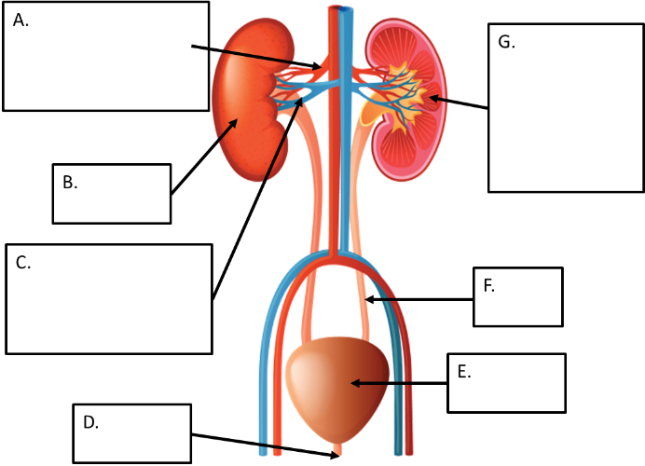
- Name the structures in the kidneys where the blood is filtered.
- What are the 3 steps in the blood filtering process?
- Describe what happens in each of the 3 steps of the blood filtering process.
- HT: Where in the body are the water levels in the blood monitored?
- HT: Name the hormone that controls the water levels in the blood.
- HT: What effect does increased levels of this hormone have on the kidneys?
- HT: Describe what happens in the body when the water content of the blood is too low?
- HT: Describe what happens in the body when the water content of the blood is too high?
- How does kidney dialysis treat kidney failure?
- Describe how the dialysis machine works.
- How does a kidney transplant treat kidney failure?
- State the advantages and disadvantages of kidney dialysis and kidney transplants.

