Part 1

1 Springs are used both in tension and compression.
a. Describe what is meant by tension and compression of a spring. (2)
Tension is where the spring is being stretched
Compression is where the spring is being squashed

b. Complete the table by giving two uses of springs in tension and two uses of springs in compression. (4)

Uses of springs in tension | Uses of springs in compression
newton meter | vehicle suspension spring
trampolines | mattress / bed springs
Any other relevant uses
c. Springs can be used to keep fire doors closed.

When a fire door is opened, the spring is stretched which then applies a force to close the fire door
again. Figure 1 shows how the spring is used.

A force-extension graph for the spring is shown in Figure 2.
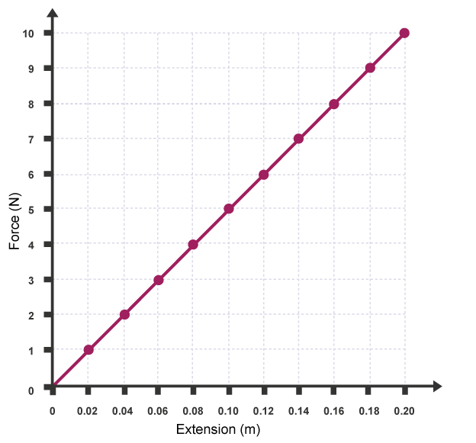
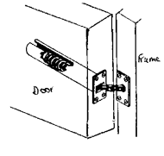
Figure 1 Figure 2

c. i) State the equation used to find the spring constant of a spring. (1)
force exerted on a spring (N) = spring constant (N/m) × extension (m) or $F=k × x$

ii) Work out the spring constant of the spring used in Figure 2. (2)
spring constant = force exerted on a spring / extension
spring constant = 10 / 0.2 = 50 N/m

iii) When the fire door is fully opened the spring is stretched 25 cm.
Work out the closing force applied by the spring when it is stretched 25 cm. (2)
Using the answer from part ii: force exerted on a spring = 50 x 0.25
force exerted on a spring = 12.5 N

iv) The fire door spring is removed from the door for testing.
During testing a force is applied to the spring and the extension is measured. The force applied to
the spring is increased until the spring snaps.
Draw the force-extension graph for the test described above. (2)
Force / N

Extension / m

d. i) Mountain bikes use springs for front suspension.
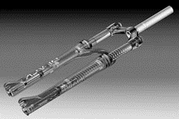

A typical mountain bike spring has a spring constant of 90 000 N/m and can be compressed 6 cm.
Use the formula given to work out the energy stored in the spring when compressed 6 cm. (2)
energy transferred in stretching = 0.5 x spring constant x extension²
$$E=\text{½} × k × x^{2}$$
E = 0.5 x 90 000 x 0.06²
E = 162 J

ii) The spring on the mountain bike is changed to adjust the suspension. A new spring is added that has
a spring constant of 120 000 N/m.

Work out the distance this new spring has been compressed if it has 2820 J of elastic potential
energy. Give your answer in mm. (2)

2820 / (0.5 x 120 000) = E²
E = √0.047 = 0.22 m

Part 2 (physics only)

1. Complete the following sentences. (3)
A fluid can be either a liquid or a gas.
The pressure in a fluid causes a force at right-angles (normal) to any surface.

2. This question is about pressure in a fluid.
a. i) State the equation that links area, force and pressure. (1)
pressure (Pa) = force normal to a surface (N) $÷$ area of surface (m²)
$$P=\frac{F}{A}$$
ii) A force of 18 N acts on a surface that has an area of 0.015 m².
Work out the pressure acting on the surface. (2)
pressure = 18 / 0.015
pressure = 1200 Pa
b. Circle the two equivalent units for pressure. (1)

m/s N/m N/m² m/s² Pa

c. A surface has an area of 25 cm².
Convert 25 cm² into m². (1)
25 cm² = 0.0025 m²

3. A stone is dropped into a lake. The lake is 8.2 m deep.
Fresh water has a density of 1000 kg/m³. The gravitational field strength on Earth is 10 N/kg.

a. Work out the pressure on the stone at the bottom of the lake. (2)
pressure due to a column of liquid = height of column $×$density of liquid$×$gravitational field strength
$$P=h × ρ × g$$

pressure = 1000 x 10 x 8.2
pressure = 82 000 Pa
b. Another stone is dropped into the sea.
Sea water has a different density to fresh water.
At a depth of 8.2 m the pressure on the stone is 84 380 Pa.
Work out the density of sea water to three significant figures. (2)
density of liquid = pressure / (gravitational field strength x height of column)
density of liquid = 1030 kg/m³
4. A student puts three holes into an empty bottle.
The holes are arranged vertically, as shown in the diagram below.
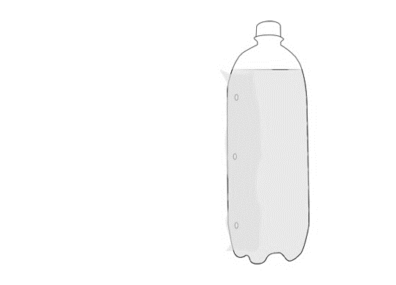
The bottle is then filled with water.

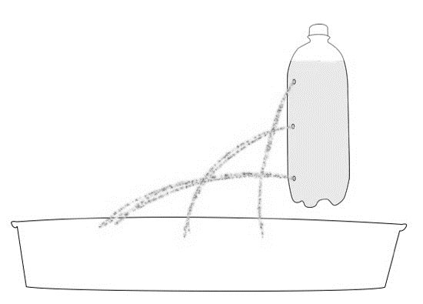
a. i) Complete the diagram to show how water will leave through the three holes. (1)

ii) Explain why the water leaves the bottle in the way that you have drawn, above. (2)
The water at the bottom of the bottle is under the greatest pressure
The liquid at the bottom of the bottle will exert a greater force on the walls of the container.

5. A submarine floats in mid-water at a depth of 47 m, to the top of the submarine.
The submarine has a height of 8.7 m. The surface area of the top and bottom surfaces of the submarine is
250 m².

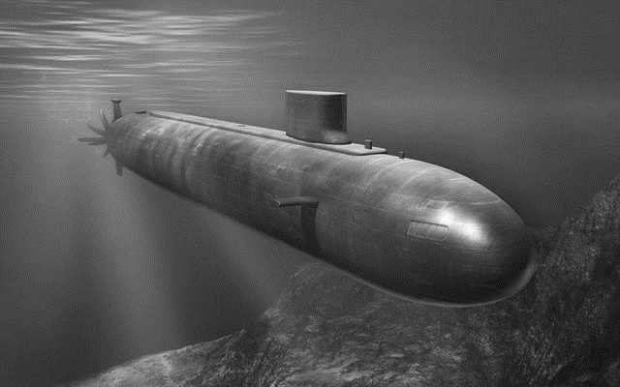

a. i) Explain why the submarine experiences an upthrust. (2)
There is a difference in pressure between the top of the submarine and the bottom of the
submarine

The difference in pressure is equal to the upthrust

ii) The density of the water is 1034 kg/m³. Take g = 9.8 N/kg.
Work out the weight of the submarine in kilonewtons, kN. (4)
Pressure difference = 1034 x 9.8 x 8.7
Pressure difference = 88 159 Pa
As pressure = force / area
Force = 88159 x 250 = 22 040 kN

iii) Submarines have ballast tanks that hold water or air inside the submarine.
To surface, the submarine puts air into a ballast tank (which expels water from the tank). Explain
why this would cause the submarine to surface? (2)

Filling the ballast tanks with air decreases the weight of the submarine
So, the upthrust is now greater than the weight causing the submarine to rise

6. A child inflates a balloon with helium. The balloon is made from rubber.
When the end of the balloon is tied the size of the balloon remains constant.
a. i) Describe the two opposing forces that act on the balloon to keep the balloon the same size. (2)
Force due to air pressure of the air inside the balloon pushing the balloon outwards
Force due to outside air pressure pushing the balloon inwards

ii) The helium balloon is released and it goes up into the sky.
Describe what happens to the size of the balloon (assume the temperature of the balloon remains
constant). Explain your answer. (2)

The balloon expands
As there is a lower pressure as you get higher (so a lower force acting inwards)

b. When mountaineers climb high mountains they usually carry oxygen with them. The mountaineers
need to carry oxygen due to changes in atmospheric pressure as you go higher.

Explain how atmospheric pressure varies with height above the Earth's surface. (2)
The higher you go the lower the pressure
As there is less weight of air pushing down

c. Complete the sentence. (1)
For air molecules to create an atmospheric pressure the air molecules must collide with a surface.

