Part 1

1. Describe the energy store changes when a rocket firework is lit, goes up in the air and then falls back
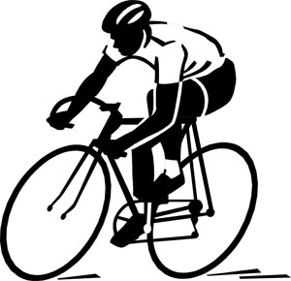
to the ground. (4)

2. A cyclist is braking hard to avoid a collision.
Describe the energy store changes as the bicycle and rider decelerate to a stop. (3)

3. When a battery stops working people often say the energy has been used up. Explain why this statement is not
correct. (2)

4. The Sankey diagram shows the simple energy store transfers for a car.
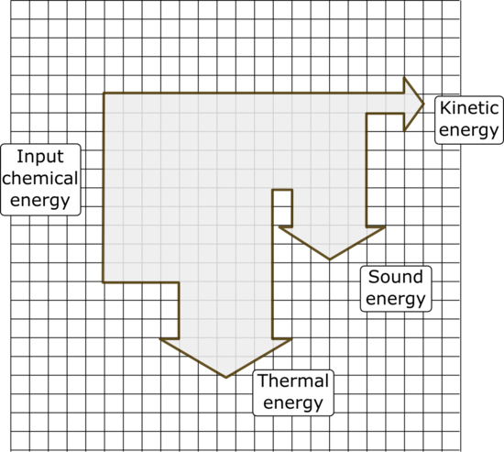

Chemical energy from the petrol = 20 000 J

- Calculate the amount of useful energy
transferred by the engine. (1)

- What is the total amount of “wasted” energy
in the system? (1)

5. An eagle has a mass of 4 kg and is flying at a velocity of 35 m/s. Calculate the kinetic energy of the bird. (3)

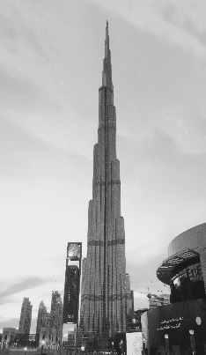
6. A 48 kg person diving off a cliff has 3500 J of stored gravitational potential energy. Calculate the height of the cliff (3)

Part 2

1. The lift in the world’s tallest building takes 64 s to reach a height of 828 m.
The maximum mass of the lift and passengers is 900 kg.
- Calculate the power of the lift. (3)

- A service lift in this building is used to move furniture to apartments in the tower.
This lift has a 130 kW motor. If the maximum load for this lift is 2000 kg, how long will it take to reach the top of the building? (3)

2. The diagram represents the energy transfers for an oil-fired power station.
Generator
Turbine
Water and steam
Oil

Energy transferred as movement
Useful energy out
X
Energy transferred as heat

- What is the useful energy out? (1)

- In what form will energy be “wasted” in this process? (1)

- What useful energy store is represented by the box labelled X? (1)

3. A company sells two types of electric drill.

Drill A Drill B
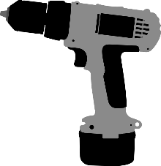

Drill A is a 300 W drill with an output power of 165 W.
Drill B is a 1100 W drill with an output power of 520 W.
Explain which drill is the more efficient at transferring useful energy? (3)

4. Describe two ways you could increase the efficiency of a household central heating system. (2)

