- Communicable and non communicable diseases (viral, bacterial, fungal and protist)
- Tuberculosis (TB) is a communicable disease caused by a bacterium. TB is spread by droplets in the air when an infected person sneezes or coughs.
- Suggest which organ will be infected first when a person contracts TB. (1)
- Explain why people who live in densely populated areas are more likely to be infected with tuberculosis than people who live in less densely populated areas. (3)
- Give reasons why a person infected by a very small number of TB bacteria may not actually develop the disease. (2)

- Polio is a communicable disease caused by a virus. It can cause irreversible paralysis which often leads to death. The following data shows the number of cases reported and deaths in the UK.
Year | Total cases of polio reported | Total deaths due to polio
1959 | 1028 | 87
1960 | 378 | 46
1965 | 91 | 19
1968 | 24 | 15
1975 | 3 | 18
1985 | 4 | 29
1990 | 1 | 1
1996 | 1 | 1

- Use graph paper and a suitable method to display the data relating to deaths from polio using the table. (4)
(Remember to add labels)

- Calculate the percentage decrease in deaths from 1959 to 1975. (2)
Give your answer to 2 significant figures and show your working.

- Suggest an explanation for the fall in the number of cases between 1959 and 1960. (1)
- Suggest why there are more deaths than reported cases in some years. (1)
- Why does the presence of one disease potentially lead to a higher susceptibility of other diseases? (2)

- Measles is a highly infectious viral disease which can be fatal. Children are normally vaccinated at 1 year of age and then again at 3 years 4 months of age.
Suggest 2 explanations why children need a follow up vaccination at 3 years 4 months of age. (2)

- Explain how the pathogen Chalara ash dieback is spread, its symptoms and how the spread can be reduced. (4)
- Smoking can cause diseases such as cancer. Explain why this is not a communicable disease. (2)
- Extended response question:
A group of Year 12 students are going from a school in the UK to Central Africa. They have purchased insecticide treated malaria nets. Explain why these nets are more effective than non- insecticide nets.
Suggest what other control measures should be put in place and why they reduce the chance of becoming seriously ill with malaria. (6)
Biology only question
- Describe the lysogenic pathway of a virus in a plant cell. (4)
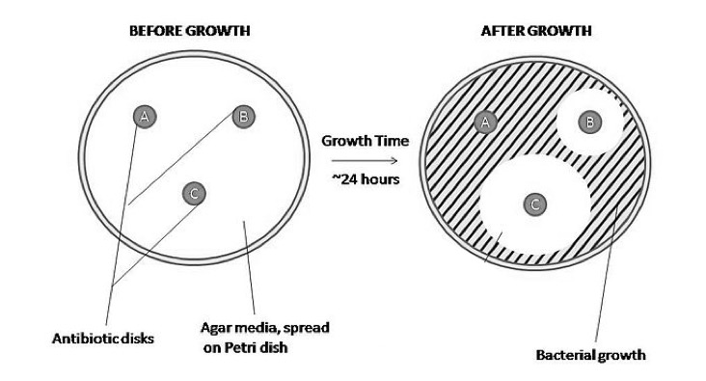
- The image below shows the results of an experiment on antibiotics.

Write a conclusion for this experiment. (4)

B: Human defence systems, vaccination and antibiotics
- The Andaman Islands of India are very remote and remain untouched by modern civilization.
A British expedition visited in order to carry out a survey of the islands. In a strategy to try and demonstrate friendliness, the expedition kidnapped an elderly couple and 4 children. The prisoners were taken to the mainland and given lots of food and gifts. After a couple of days, the prisoners were taken back to the Islands and released with gifts for the tribe.

The British expedition team was accused of starting a measles outbreak amongst the Andamese people. The outbreak killed the elderly couple and left many others very ill. Nobody on the expedition team was ill.

Explain how this could be possible. (3)

- The sketch graph shows the rate of antibodies production when a person becomes infected with the chicken pox virus. Annotate the graph below to describe what is occurring at each of the 4 stages of the immune response to the pathogen. (5)
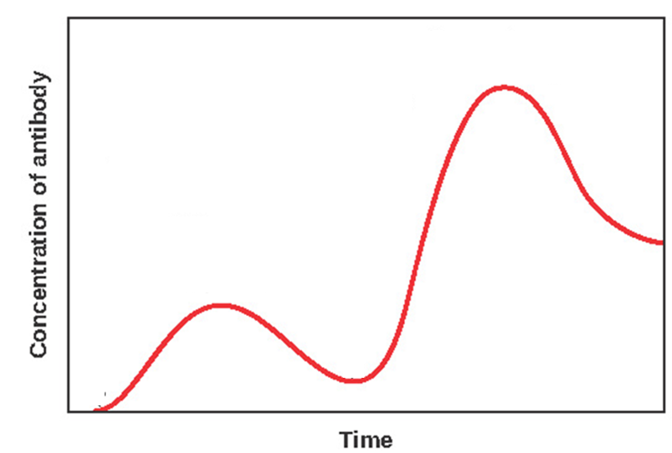
D
C
B
A

- Extended response question:
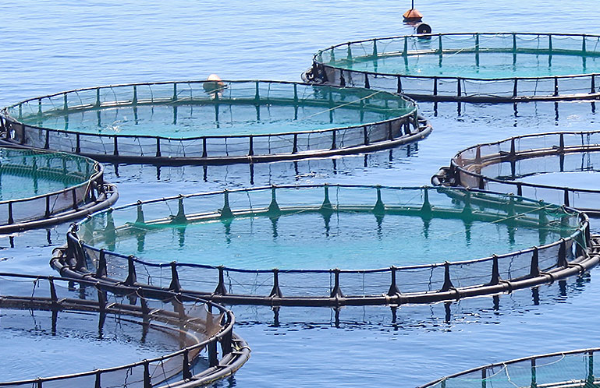
A salmon farm uses large quantities of antibiotics to increase fish production. Large numbers of salmon of similar ages are kept together in tanks
Describe the economic benefits and costs of this approach. (6)

- Biology only question
The measles vaccine is now combined with that for two other serious diseases - mumps and rubella. This is called the MMR vaccine. Measles can lead to serious complications such as pneumonia, blindness, miscarriage in pregnant women and inflammation of the brain (encephalitis).
The table below shows the risk of a complication occurring in children who have had the MMR vaccine and in unvaccinated children who get infected with measles.
Complication | Statistical risk associated with the MMR vaccine | Statistical risk associated with a measles infection
Diarrhoea | 0 | 1 in 6 people
Ear infection | 0 | 1 in 20 people
Pneumonia | 0 | 1 in 25 people
Fits (convulsions) | 1 in 1000 people | 1 in 200 people
Meningitis/encephalitis | 1 in 100 000 people | 1 in 1000 people
Severe allergic reaction | 1 in 24 000 people | 0
Death | 0 | 1 in 5000 people
Serious brain complications | 0 | 1 in 8000 people

Using the information from the table above and your own knowledge, describe the benefits to the individual, family and wider community of a parental decision to vaccinate their child and suggest why some parents may decide not to vaccinate their child. (5)

C. Discovery and development of drugs, monoclonal antibodies (HT Biology only)
- Why in the past might people have chewed on the bark of a willow tree if they had a headache? (2)
- a) Drug trials are used to find out about dosage.
Why is this important both to the patient and economically? (2)

b) In the initial stages of a clinical trial a low dose of the drug is used on healthy volunteers.
Suggest why this is not used with patients at this point. (2)
- Traditionally drugs were extracted from plants or micro-organisms. Most new drugs are now made in a laboratory, but the initial starting point may still have been a naturally occurring chemical in a plant.
Suggest why it is advantageous to use synthetic drugs rather than extracting it from a plant. (2)

- Some people have severe allergic reactions to monoclonal antibodies. Why might this occur? (2)

5. Extended response question: (Biology HT only)
Evaluate the personal benefit of using monoclonal antibodies for diagnostic testing. (6)
D: Plant defence (Biology only)
- Suggest how the following plants have evolved to defend themselves against pathogens and herbivores. (6)
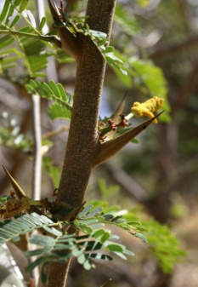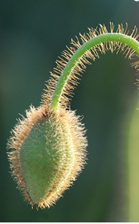
Plant B has hollow thorns which are colonised by ants
C
B
A
Cody Hinchliff 2004 - English Wikipedia

